ETL and Data Pipelines with Shell, Airflow and Kafka Project

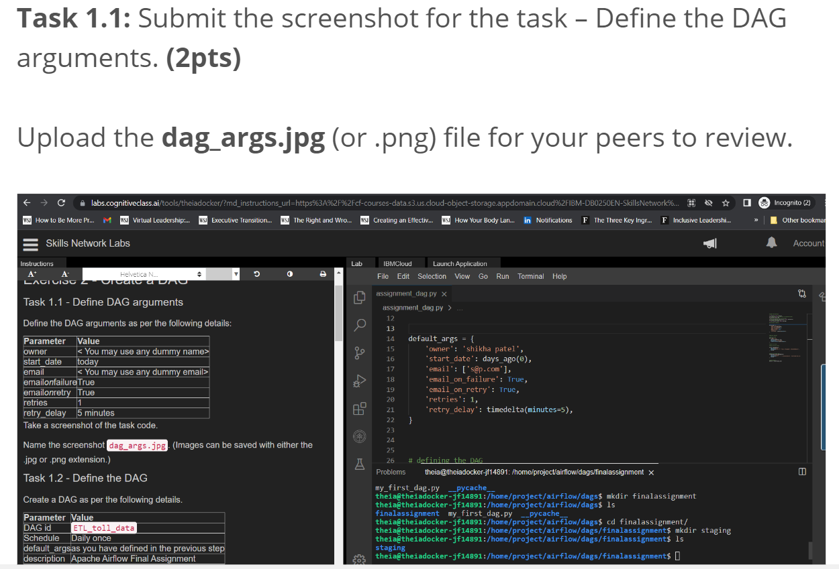

Or

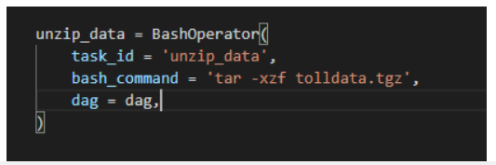

Or

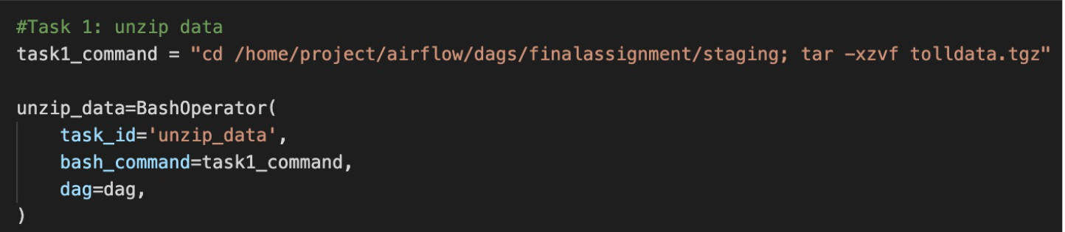



Or

Or



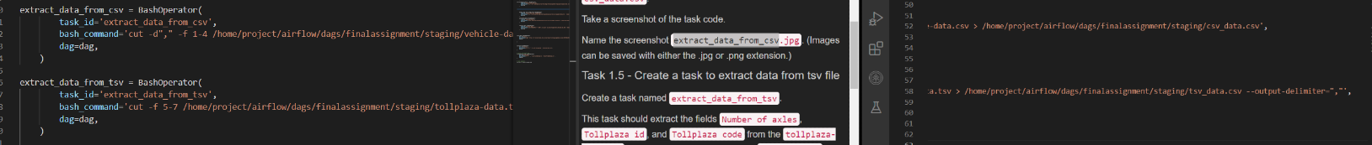

Or

Or



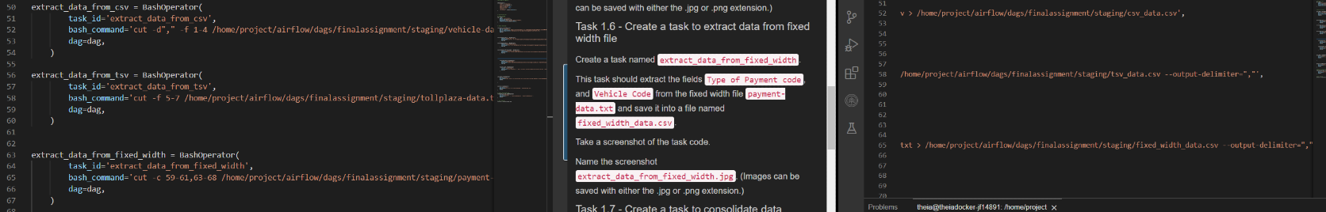

Or

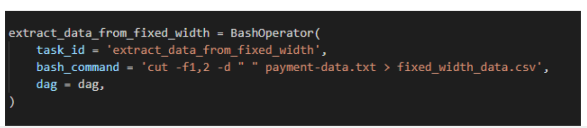

Or

Or

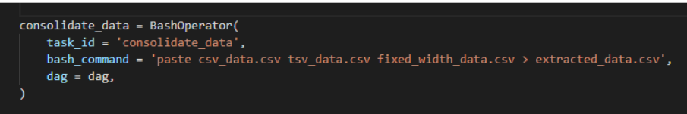

Or

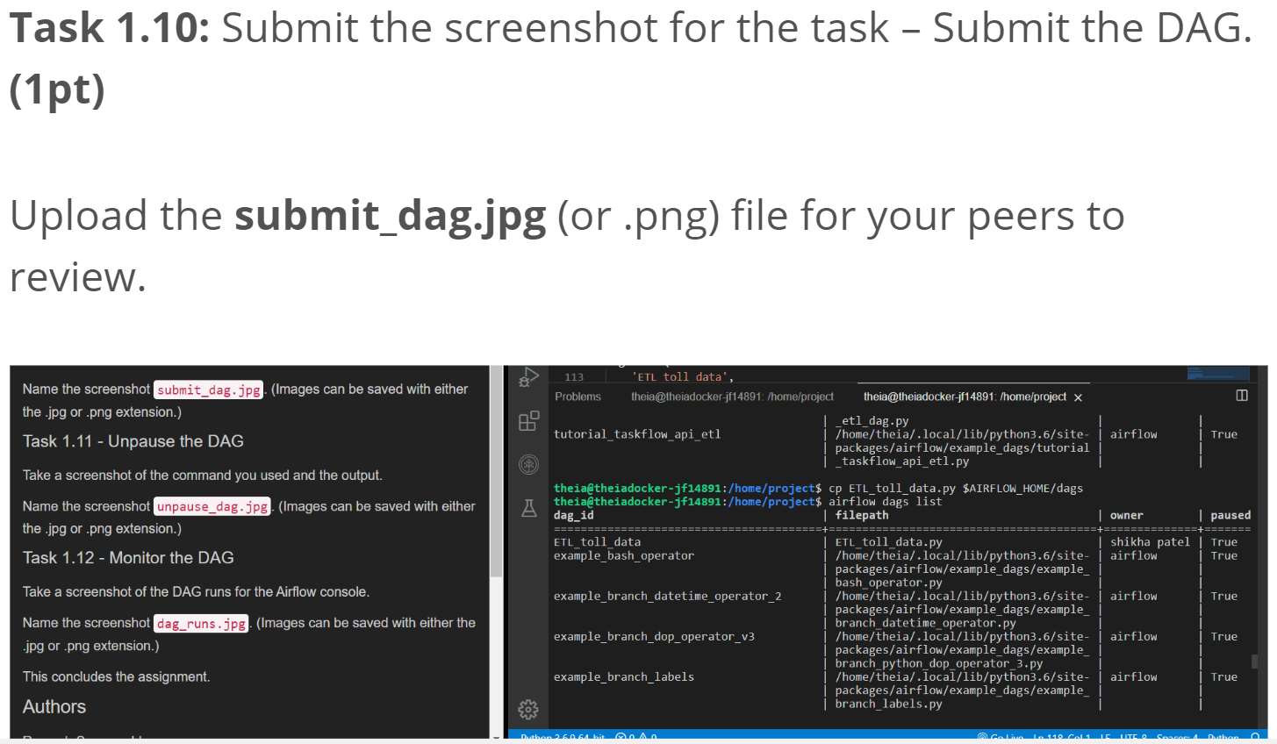

Or preferred below one



